**Name: ___________________________________________**



**The** [**Modern**](http://k10outline.scsa.wa.edu.au/home/p-10-curriculum/curriculum-browser/humanities-and-social-sciences/humanities-overview/glossary/modern) **World and Australia**

***5 minutes reading time and 50 minutes working time***

|  |  |  |
| --- | --- | --- |
| Total marks:  70 | **%** | Weight  20% |
|  |  |  |

**Civics & Citizenship and Modern History Exam**

***My Target: ________/70 or, _________%***

1. What is a constitution? (3 marks)

___________________________________________________________________

___________________________________________________________________

___________________________________________________________________

___________________________________________________________________

2. Put the following words into the correct spaces in the text below. (8 marks)

|  |
| --- |
| **Australia function settle allowed high meaning**  **constitution court 1903 state legislation government parts**  **unconstitutional Commonwealth tier** |

People are ___________________ to test the meaning and application of the Australian

___________________. It is the principal ____________________ of the

________________ Court of ____________________________ to interpret the

Constitution and to _______________ disputes about its _____________________. The

high ______________, established in ______________, has the power to consider

_____________________________ or ____________ legislation and determine whether

such ____________________________ is within the powers granted in the Constitution to

the relevant _____________ of ______________________. The High Court can invalidate

any legislation or __________________ of legislation that it finds to be ________________.

**Source 1**

Numbers of Deaths

Death figures for World War Two vary from source to source. The figures below are believed to be reasonably accurate.

|  |  |  |  |
| --- | --- | --- | --- |
| Country | Military | Civilian | Total |
| USSR | 12 million | 15 million | 27 million |
| China | 1.8 million | 7.5 million | 9.3 million |
| Poland | 400,000 | 5.86 million | 6.26 million |
| Germany | 3.25 million | 2.44 million | 5.69 million |
| Japan | 1.5 million | 500,000 | 2 million |
| Yugoslavia | 305,000 | 1.35 million | 1.66 million |
| Romania | 450,000 | 465,000 | 915,000 |
| Hungary | 200,000 | 600,000 | 800,000 |
| France | 245,000 | 350,000 | 595,000 |
| Great Britain | 403,000 | 92,700 | 495,000 |
| Italy | 330,000 | 100,000 | 430,000 |
| Austria | 280,000 | 125,000 | 405,000 |
| United States | 407,000 | 6,000 | 413,000 |
| Greece | 60,000 | 350,000 | 410,000 |
| Czechoslovakia | 7,000 | 315,000 | 322,000 |
| Netherlands | 13,700 | 236,000 | 249,000 |
| Philippines | 27,000 | 91,000 | 118,000 |
| Belgium | 23,000 | 76,000 | 99,000 |
| Finland | 80,000 | 10,000 | 90,000 |
| Bulgaria | 10,000 | 51,000 | 61,000 |
| Canada | 39,000 |  | 39,000 |
| Australia | 35,000 |  | 35,000 |
| Albania | 20,000 | 10,000 | 30,000 |
| India | 25,000 |  | 25,000 |
| New Zealand | 17,000 |  | 17,000 |
| *Civilian numbers include those killed as a result of the Holocaust* | | | |

3. State which country had the highest number of combined military and civilian deaths during World War Two? (1 mark)

_________________________________

4. State which country had the lowest number of both military and civilian deaths during World War Two? (1 mark)

________________________________

5. Calculate the total number of civilian deaths in both France and Great Britain?

(1 mark) ________________________________

6. Calculate how many countries lost more civilians than military personal? (1 mark)

________________________________

7. Why do you think the United States only lost 6,000 civilians? (1 mark)

_________________________________

8. Outline the things Germany had to do as a result of the Treaty of Versailles.

(4 marks)

___________________________________________________________________

___________________________________________________________________

___________________________________________________________________

___________________________________________________________________

___________________________________________________________________

___________________________________________________________________

___________________________________________________________________

___________________________________________________________________

___________________________________________________________________

___________________________________________________________________

9. Who led the German Nazi regime into World War II? (1 mark)

_________________________________________________________________

10. List two of the AXIS powers of World War II. (2 marks)

________________________________ ____________________________

11, List two of the Allied powers of World War II. (2 marks)

_______________________________ _____________________________

12. Create three neat lines to correctly match the following. (3 marks)

Legislature Carrying out or executing the law

Executive Judging or adjudicating on the law

Judiciary Law-making

13. Briefly describe how organised crime can influence or threaten Australia’s democracy. (4 marks)

___________________________________________________________________

___________________________________________________________________

___________________________________________________________________

___________________________________________________________________

___________________________________________________________________

___________________________________________________________________

___________________________________________________________________

14. Complete the ‘Total’ column of the table below which shows the numbers of women participating in various roles in the Australian defence forces during World War 2. (4 marks)

|  |  |  |  |
| --- | --- | --- | --- |
| Service | Medical/nurses | Auxiliary | Total |
| Army | 11 500 | 24 000 |  |
| Navy | 60 | 3 000 |  |
| Air-Force | 600 | 27 000 |  |
| Total | | |  |

15. Use three lines to match the following. (3 marks)

Cause & Effect Any item of information that relates to the

topic being studied, such as a book, letter,

diary or tool.

Source To see something from an alternative

viewpoint

Empathy Events in history are created by several

factors that combine to make something

happen.

16. Who did the Germans blame for losing World War I? (2 marks)

_____________________________________________

17. State the event that finally caused Japan to surrender to the Allies at the end of World War II. (1 mark)

______________________________________________________________

18. Explain why it was vital for Australian soldiers to defend Port Moresby and push the Japanese out of New Guinea during World War II. (2 marks)

___________________________________________________________________

___________________________________________________________________

___________________________________________________________________

___________________________________________________________________

___________________________________________________________________

19. Study the image below (Source 2) and respond to the tasks that follow.

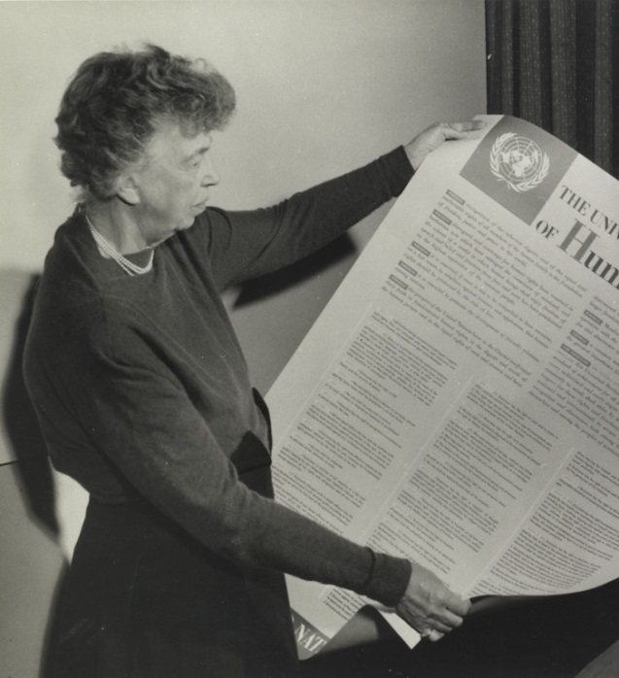**Source 2**

(a). Identify the person represented in source 2.

__________________________________________ (1 mark)

(b). What does UDHR stand for?

__________________________________________ (2 marks)

(c). Identify the year that the UDHR was produced.

__________________________________________ (1 mark)

(d). How many human rights are listed on this document?

__________________________________________ (1 mark)

(e). Identify the prominent Australian who was President of the United Nations during 1948 - 1949.

__________________________________________ (1 mark)

**Multiple Choice**

***Use the answer sheet provided to record your responses to this section.***

**1.** **The Separation of Powers in Australian government is between**: **(1 mark)**

1. Judicial, Executive and Legislative
2. Local, State and Federal
3. The Axis powers and the Allied powers

D. Conciliation, Mediation and Arbitration

**2.** **The Three Levels of Australian government is**: **(1 mark)**

A. Judicial, Executive and Legislative

B. Local, State and Federal

C. The Army, Air Force and Navy

D. Conciliation, Mediation and Arbitration

**3.** **Conciliation, Mediation and Arbitration are all examples of:** **(1 mark)**

1. The Separation of Powers
2. The Three Arms of Government
3. Dispute resolution
4. A constitution

**4.** **Acting towards others with courtesy is a demonstration of**: **(1 mark)**

1. Precedent
2. Organised crime
3. Corruption
4. Civility

**5.** **The practices and customs of an indigenous culture that can have an impact**

**on** **decisions in lawmaking is known as:**  **(1 mark)**

1. Common Law
2. A precedent
3. Customary Law
4. Civility

**6.** **Another term for a referendum is a:**  **(1 mark)**

1. A Constitution
2. A Diktat
3. A Plebiscite
4. A Precedent

**7.** **The voting system that states that the candidate who gets the largest**

**number of votes wins, is termed as:**  **(1 mark)**

1. First Past the Post
2. Preferential Voting
3. Proportional Voting
4. A Referendum

**8.** **An example of a threat to democracy is:**  **(1 mark)**

A. A plebiscite

1. Corruption
2. Conciliation
3. Bicameral

**9. Another term for payments for damages is: (1 mark)**

A. Diktat

B. Referendum

C. Reparations

D. Arbitration

**10. Which three major powers challenged the power of the League of Nations**

**during the 1930s?** **(1 mark)**

1. Britain, France and the USA
2. Britain, Japan and Italy
3. The USA, Germany and Italy
4. Japan, Italy and Germany

**11.** **The Men, Money and Markets Policy of Australia relied on the support of:**  **(1 mark)**

1. Britain
2. The USA
3. The League of Nations
4. The United Nations

**12.** **The effects of the Great Depression ended due to:**  **(1 mark)**

1. The start of World War One
2. The start of World War Two
3. The League of Nations
4. The United Nations

**13.** **The Nazi Party of Germany was encouraged to make increased demands because of the use of:**  **(1 mark)**

1. Reparations
2. The War Guilt Clause
3. Appeasement
4. The United Nations

**14.** **What major historical event occurred on 15 Feb 1942:**  **(1 mark)**

1. The attack on Pearl Harbour
2. The Fall of Singapore
3. The Battle of Kokoda
4. The dropping of the Atom Bomb on Hiroshima

**15.** **What percentage of POWs died at the hands of the Japanese during World**

**War Two:**  **(1 mark)**

1. 34%
2. 48%
3. 8%
4. 60%

**16.** **Which one of the following is not a branch of the United Nations? (1 mark)**

A. General Assembly

B. Secretariat

C. Economic and Social Council

D. Environmental Trusteeship Council

**17.** **Which historical figure identified ‘Natural Law’ and freed the slaves from the lands he conquered?** **(1 mark)**

1. Cyrus the Great
2. King John
3. Napoleon Bonaparte
4. Gandhi

**18.** **Which leader signed the Magna Carta, stating that even a monarch could not overrule the rights of people?** **(1 mark)**

1. Cyrus the Great
2. King John
3. Napoleon Bonaparte
4. Gandhi

**19.** **Which European leader tried to use their power to overrule the Natural Rights of the people?** **(1 mark)**

1. Cyrus the Great
2. King John
3. Napoleon Bonaparte
4. Gandhi

**20.** **Which historical figure identified that ‘All people on Earth’ have rights, not just those people from the major European powers?** **(1 mark)**

1. Cyrus the Great
2. King John
3. Napoleon Bonaparte
4. Gandhi